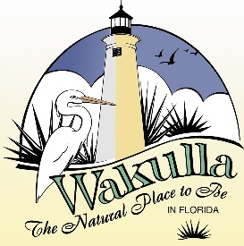 FOR IMMEDIATE RELEASE
December 1, 2015

Contact: Diane Bardhi, (850) 926-0919 ext. 716 or dbardhi@mywakulla.com

Crawfordville, FL-December 1, 2015 - The Wakulla County Tourist Development Council is pleased to announce the opening of the annual Wakulla County TDC Grant Program application cycle.

The purpose of the grant program is to provide limited funding to organizations that sponsor and promote tourism activities in Wakulla County. Requests for funding from the TDC for local tourism events/projects will not be received by the Council except through the grant application process.

Application forms and criteria can be obtained by contacting Diane Bardhi, Outreach Coordinator, Wakulla County TDC, P.O. Box 1263, Crawfordville, Florida 32326, or dbardhi@mywakulla.com or (850) 926-0919 ext.716. Applicants must use the application form provided and all applications must be received by 5:00 p.m. on January 22, 2016. Applications (in Word or pdf format) can be emailed to dbardhi@mywakulla.com.
Questions or requests for additional information should be directed to Diane Bardhi, Wakulla County TDC, P.O. Box 1263, Crawfordville, Florida 32326, dbardhi@mywakulla.com, (850) 926-0919 ext. 716.

###

